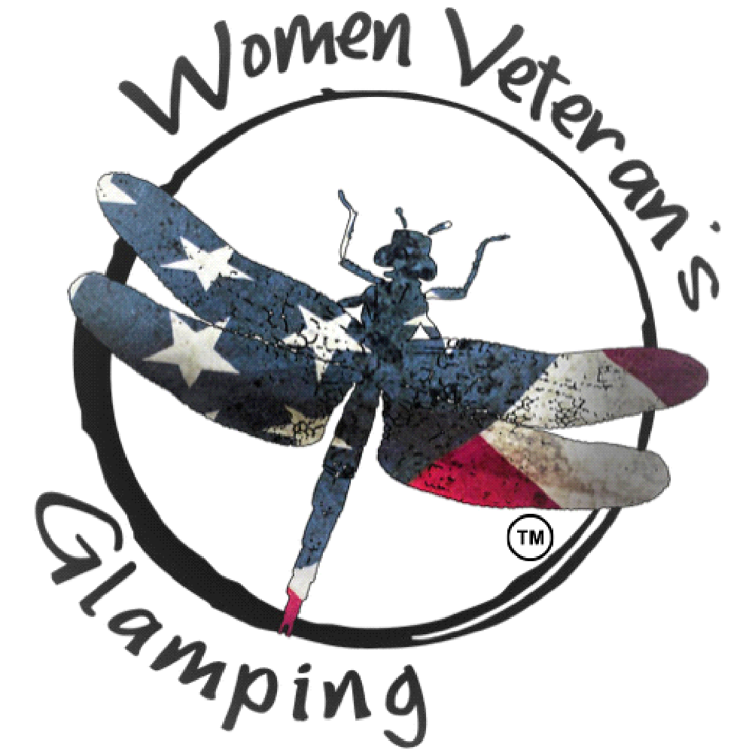
Liability Waiver 2026
- EXCULPATORY CLAUSE: In consideration for receiving permission to participate in any and all activities of ANY AND ALL WOMEN VETERAN’S GLAMPING ORGANIZATION EVENTS HELD IN 2026 (herein referred to as “Activity”), in which is sponsored by the Women Veteran’s Glamping organization for Women Veterans, a Maine nonprofit organization (herein referred to as “WVG”), I hereby release, waive, discharge, covenant not to sue, and agree to hold harmless for any and all purposes WVG and its owners, members, officers, servants, agents, volunteers, or employees (herein referred to as RELEASES or INDEMNITEES) from any and all liabilities, claims, demands, injuries (including death), or damages, including court costs and attorney’s fees and expenses, that may be sustained by me while participating in such Activity, while traveling to and from the Activity, or while on the premises owned or leased by RELEASES, including injuries sustained as a result of the sole, joint, or concurrent negligence per se, statutory fault, or strict liability of RELEASES. I understand this waiver does not apply to injuries caused by any intentional or grossly negligent conduct.
- INDEMNITY CLAUSE: I am fully aware that there are inherent risks to myself, and others involved with this Activity, including but not limited to physical injury, and I chose to voluntarily participate in said Activity with full knowledge that the Activity may be hazardous to me and my property, and to the person and property of others. I acknowledge there may be physical strenuous activities. I know of no medical reason why I should not participate. I agree to indemnify and hold harmless INDEMNITEES from any and all liabilities, claims, demands, injuries (including death), damages, including court costs and attorney’s fees and expenses, which may occur to myself, other participants, and third persons as a result of my participation in said Activity, including injuries sustained as a result of the sole, joint, or concurrent negligence, negligence per se, statutory fault, or strict liability of INDEMNITEES.
- No INSURANCE. I understand that RELEASES may or may not maintain any insurance policy covering any circumstance arising from my participation in this Activity or any event related to that participation. As such, I am aware that I should review my own personal insurance coverage. WVG may not carry general liability insurance to cover claims arising from this Activity so it seeks a waiver of claims as additional consideration for the right to participate so WVG, can (a) provide the Activity at the lowest possible cost to participants; and (b) provide access to a greater number of participants by expanding limited resources on program materials rather than on liability insurance.
- BINDS HEIRS. It is my express intent that this agreement shall bind the members of my family and spouse, if I am alive, and my heirs, assigns and personal representatives, if I am deceased, and shall be governed by the laws of the State of Maine.
- MEDICAL AUTHORIZATION, INDEMNITY FOR MEDICAL EXPENSES, and WAIVER. I understand RELEASES cannot be expected to control all of the risks articulated in this form and RELEASES may need to respond to accidents and potential emergency situations. Therefore, I hereby give my consent for any medical treatment that may be required, as determined by a medical professional at the medical facility, during my participation in this Activity with the understanding that the cost of any such treatment will be my responsibility. I agree to indemnify and hold harmless INDEMNITEES for any cost incurred to treat me, even if an INDEMNITEE has signed hospital documentation promising to pay for the treatment due to my inability to sign the documentation. I further agree to release, Waive, discharge, covenant not to sue, and agree to hold harmless for any and all purposes, RELEASEES from any and all liabilities, claims, demands, injuries (including death), or damages, including court costs and attorney’s fees and expenses, that may be sustained by me while receiving medical care or in deciding to seek medical care, including while traveling to and from a medical care facility, including injuries sustained as a result of the sole, joint, or concurrent negligence, negligence per se, statutory fault, or strict liability of RELEASES. I understand this waiver does not apply to injuries caused by any intentional or grossly negligent conduct.
- VOLUNTARY SIGNATURE. In signing this agreement, I acknowledge and represent that I have read it, understanding it, and signed it voluntarily as my own free act and deed; WVG- Women Veteran’s Glamping has not made and I have not relied on any oral representations, statements, or inducements apart from the terms contained in this agreement. I execute the document for full, adequate, and complete consideration fully intending to be bound by the same, now and in the future. I understand I can choose not to sign this document and free myself from its terms and the associated risks of the Activity by simply not participating in the Activity and choosing some other Activity. While I understand alternative activities are available to me that do not have risks associated with this Activity I still desire to voluntarily engage in this Activity.

SIGNING THIS DOCUMENT INVOLVES THE WAIVER OF THE VALUABLE LEGAL RIGHTS. CONSULT YOUR ATTORNEY BEFORE SIGNING THIS DOCUMENT.
SIGNED this__________ day of ______________________, 2026.

Participants Signature: __________________________________________________

Printed Name: _________________________________________________________

Participant’s Date of Birth: __________________________________

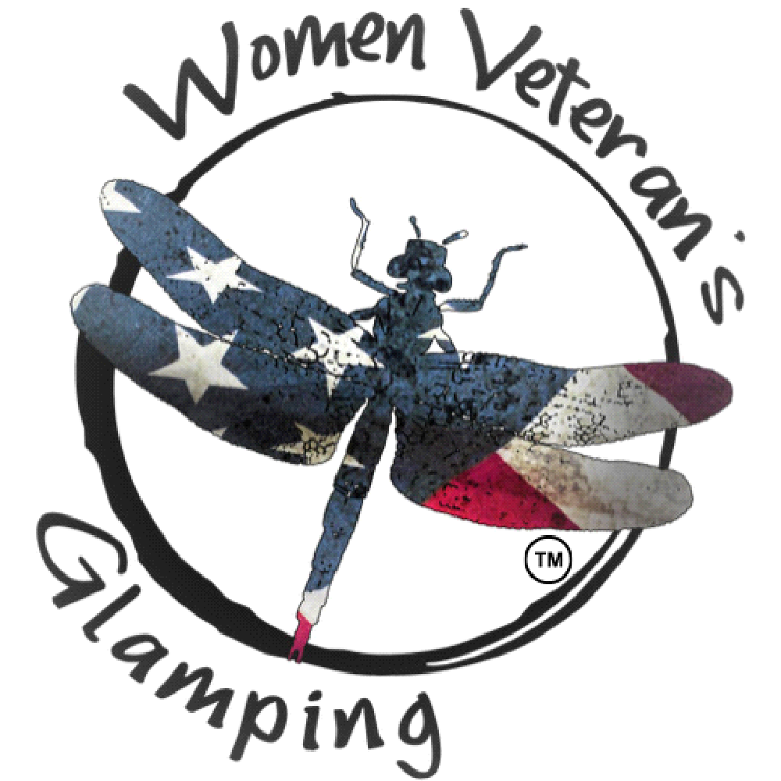 2026

